Checklists regarding installation

Checklist prior to completion of TECDIS installation

Item: | Task to be performed: | OK: | Comments
1 | Verify that all selected ports are receiving/transmitting data, and that ports have been given names on both main and back-up TECDIS. Names shall be according to the data they are receiving/transmitting.
2 | Verify that sensor data is correctly distributed between main and back-up TECDIS (NMEA server program).
3 | Verify that one single action do not result in loss of position on both main and back-up TECDIS.
4 | Verify that main and back-up TECDIS and respective equipment are connected to a proper UPS.
5 | Verify that boat size are correct compared to chart on both main and back-up TECDIS.
6 | Perform monitor color calibration on main and back-up TECDIS.
7 | Verify that alarm function on both main and back-up TECDIS is working properly.
8 | Check that TECDIS transmits alarm to external systems.
9 | If installed, verify generation of conning picture and correct display of sensor data on conning monitor (check against engine telegraph, speed repeaters, gyro repeaters etc)
10 | Verify audible signal from alarm speaker on TECDIS
11 | Verify sensor data (correct size of vessel etc) is filled in on main and back-up TECDIS.
12 | Verify that back-up of default setup values have been performed (save setup default values) on main and back-up TECDIS.
13 | Verify that installed charts have been correctly installed on both main and backup TECDIS (if installed), and that charts license matches.
14 | Unplug TECDIS USB-key, restart TECDIS to verify it starts up in normal mode (chart program starts automatically) and boat symbol and sensor data are displayed.
15 | If connected to internet, verify that a switch is available to disconnect TECDIS from internet when the connection is not in use.
16 | Fill in hardware/software fact sheet and file it in ships documents, in technician personal files and send a copy to Furuno Norway or Telko AS.

Item: | Hardware | Model/type: | Serial no.
17 | Keyboard Main
18 | Keyboard Back-up
19 | Processor Main
20 | Processor Back-up
21 | Telchart alarm interface
22 | Trackball Main
23 | Trackball Back-up
24 | Analog signal collector
25 | Monitor Main
26 | Monitor Back-up
27 | Conning monitor
28 | Conning monitor Back-Up
29 | Alarm loudspeaker
30 | MOXA interface
31 | AUTOPILOT
32 | Additional units
33 | Additional units
Item: | Software | Version: | Comments:
34 | TECDIS Main
35 | TECDIS Back-up
36 | AUTOPILOT
37 | Additional software
38 | Additional software
Item: | License | Number: | Comments:
39 | TECDIS license # Main
40 | TECDIS license # Back-up
41 | Sent TSZ-files tsz@tecdis.no

Vessel Name / ID:
Date of installation:
Name of technician and company:
Checklist performed (Sign):
This checklist shall be filled in and signed for all TECDIS installations, in order to verify proper installation of the ECDIS system onboard.

Checklist prior to completion of TECDIS TCS and TECDIS AW installation

If installation includes Track Control functionality, the following tests must be performed.

 | TECDIS 1 and 2
No. |  | Function | Requirement | Results
Harbor Acceptance Test (15 minutes)
1 |  | External data | Go to setup menu and verify NMEA inputs are valid. Check input values for position and course. | TECDIS 1:  □Good □NG □N/A  TECDIS 2:  □Good □NG □N/A
2 |  | External data | Verify that TECDIS receives valid sensor data from a minimum of:  - Two independent positioning sensors  - Two independent heading sensors  - A speed sensor | TECDIS 1:  □Good □NG □N/A  TECDIS 2:  □Good □NG □N/A
3 |  | Alarm system | Verify that TECDIS is connected to a separate alarm system. | TECDIS 1:  □Good □NG □N/A  TECDIS 2:  □Good □NG □N/A
4 |  | System status | Check that no alarms/warnings are pending in alarm window. | TECDIS 1:  □Good □NG □N/A  TECDIS 2:  □Good □NG □N/A
5 |  | Chart database | 1,Select setup menu, chart utilities, chart licenses  2,Verify that licenses are valid for intended voyage  3,Click C-Map chart update  4,Verify that charts are updated in update log | TECDIS 1:  □Good □NG □N/A  TECDIS 2:  □Good □NG □N/A
Sea Trial Test (15 minutes)
6 |  | AIS and ARPA Targets  (If present) | 1,Activate ARPA on radar and select a target.  2,Click the symbol button of [ARPA Targets].  3,Click the symbol button of [AIS Targets].  AIS and ARPA Targets are displayed on the top of charts. | TECDIS 1:  □Good □NG □N/A  TECDIS 2:  □Good □NG □N/A
7 |  | Conning display (If present) | Correct indication is shown at the each configured window on the Conning Display. Verify that selected sensors used by heading, position is correctly indicated. | TECDIS 1:  □Good □NG □N/A  TECDIS 2:  □Good □NG □N/A
8 |  | Route Monitoring | Before start TEST, routes must be created or transferred from other TECDIS:  1,Press the [Plan] key, icon with number 1 indicated is active. This means primary route will be selected. Choose a route with boathook icon.  2,Press [YES] icon to activate route.  3,Route is then shown on displayed charts.  4,To display secondary route choose icon with button 2 indicated. Repeat procedure as for primary route.  5 To exchange primary and secondary route, press icon with 1↔2 indicated.  6. Observe that correct warnings is activated as appropriate.  7. Click alarm icon for display of alarms and warnings on route.  8. Test that activating track steering is successful. | TECDIS 1:  □Good □NG □N/A  TECDIS 2:  □Good □NG □N/A
9 |  | Radar overlay  (If present) | Check that radar overlay from radar is displayed on display after pressing radar overlay icon. | TECDIS 1:  □Good □NG □N/A  TECDIS 2:  □Good □NG □N/A
10 |  | Aids to navigation | Verify that TECDIS handle different functions like;  - Disconnect position sensors and observe dead reckoning performance, verify that alarm is given: pos sensor ½ lost.  - Activate track dialog and set past tracks visible by clicking on “show” icon.  - Enter manual fix, by activating “bearing” icon. Click on center button on mouse when mouse is in position of visual object. Use observed gyro bearing to make a red line in chart towards estimated position. Repeat procedure to make two lines resulting in a cross bearing.  - Update charts, enter chart utilities menu, choose C-Map charts update. Use semi-auto update. Create a update request file on memory stick.  Send file to updates@c-map.no and load received file into TECDIS. Update loaded successfully shall be presented when update Is completed.  - Activate a route in route menu. To alter at route underway, click on “Edit” icon in route menu. Modify route and click on “OK” icon. Route is now altered. When at track steering mode, 3 waypoints are not allowed to alter, last waypoint, next waypoint and waypoint after next.  - Manual adjustment for position is available in setup menu, click on “nav. position offset” icon and a dialog box appear in top right corner of map. Enter offset values as appropriate. | TECDIS 1:  □Good □NG □N/A  TECDIS 2:  □Good □NG □N/A

 | Autopilot type (tick one box only):
□ Anschütz NP 2025 PLUS Adaptive Autopilot
□ Furuno FAP 2000 Autopilot
□ EMRI SEM 200 Autopilot

No. |  | Function | Requirement | Results
Harbor Acceptance Test (15 minutes)
1 |  | External data | Correct number is shown at each box of below.  “Heading”, “Speed” | □Good □NG □N/A
2 |  | Heading Control | 1,[HEADING CONTROL] is activated when steering mode switch is set to “auto”. Present heading is displayed in heading display and in preset heading display. Present heading is activated as set heading.  2. Verify parameter settings for rudder, yawing, counter rudder, rudder limit, ROT limit and radius value. Verify mode of heading change, radius or R.O.T. mode by observing key lamp.  3. Alter set course by either turn knob and push set button to acknowledge or push and turn knob. Observe correct rudder response.  4. Observe rudder movement.  5. Observe that max rudder limit is not exceeded. | □Good □NG □N/A
3 |  | Steering Control | 1,Rudder moves to 10 degrees PORT when SET HEADING is set by 20 degrees below Gyro heading.  2,Confirm the actual rudder angle by rudder angle indicator. | □Good □NG □N/A
4 |  | Function | 1. Change operating mode from hand to heading control at Track Control TECDIS , verify that correct mode is indicated on TECDIS and conning monitor also.  2. Shift from heading control to manual mode by switching steering mode selector. Verify that change to manual mode is possible from all modes with a single operator action. | □Good □NG □N/A
5 |  | Function | 1. Change set course 50 deg to starboard, off-heading alarm not to be activated during setting of new course. Alarm is de-activated for a time period that is a function of present course and new desired course. | □Good □NG □N/A
6 |  | Function | Test override tiller in modes: hand, heading control and track control. Autopilot to go to hand | □Good □NG □N/A
Sea trial test (240 minutes)
1 |  | Heading Control | Response and stability of "Heading Control” steering.  1,Observed overshooting should max 2 deg on 10 deg course change and max 5 deg on 60 deg course change.  2,Repeat another side course change with same value.  Starboard 10 deg turn with NAV FULL speed (If available).  Port 10 deg turn with NAV FULL speed (If available).  Starboard 60 deg turn with NAV FULL speed.  Port 60 deg turn with NAV FULL speed.  Tests to be repeated with half speed ahead. | □Good □NG □N/A
2 |  | EMC | Testing of interference of radio transmissions while in heading control, observe system while:  - Transmitting a call with FS-2570  - Transmitting a call with VHF’s  - Transmitting a message with Felcom-15 1&2  - Transmitting a call with Felcom-70 | □Good □NG □N/A
2 |  | Track Control Steering | Steering function test should be performed as follow in the next lists "Track Control Test " and “Fail to Safe Properties” | □Good □NG □N/A

Track Control System Test
Items to be checked during sea trial

No. | Item | Content | Result | Remarks
1 |  | The following units have to be tested prior  to the Track Control test:  ECDIS  AUTOPILOT  STEERING GEAR
2 | Route | Create a test route for Track Control in keeping with the vessel maneuverability as per shown example attached (or import by file).
3 | Route monitoring | - Enter route menu, check that icon “1” is activated (primary route). Use boathook to select route from previous test item. Click yes when asked to activate route.  - Check that route monitoring parameters are shown in right menu (XTE, next waypoint info etc. )
4 | Track keeping | 1. Check that ship follows the test route  selected on ECDIS. *Recommend test speed is normal sea speed  2. Check performance according item 1 with speed reduction applied in one turn.  3. Check performance according item 1 with inducing current effect by using bow thruster during turn.
5 | Alarms | 1. Set WP pre-warning and WP approach time on the ECDIS as per drawing below. Verify that WP approach Alarm is generated when the ship approaches the WP.  2. Verify that separate Alarm system activates back-up navigator alarm when WP pre-warning and WP alarm on ECDIS is not acknowledged.  3. Set alarm for gyro mismatch to minimum in TECDIS Setup program. Wait for alarm to be raised.  4. Activate route and use “Heading Control” mode on autopilot. Steer outside channel limit to generate XTE alarm.  5. Set “Heading off” alarm low and use bow thruster to provoke a heading drift. Verify that alarm is raised.
Example of route for Track Control testing
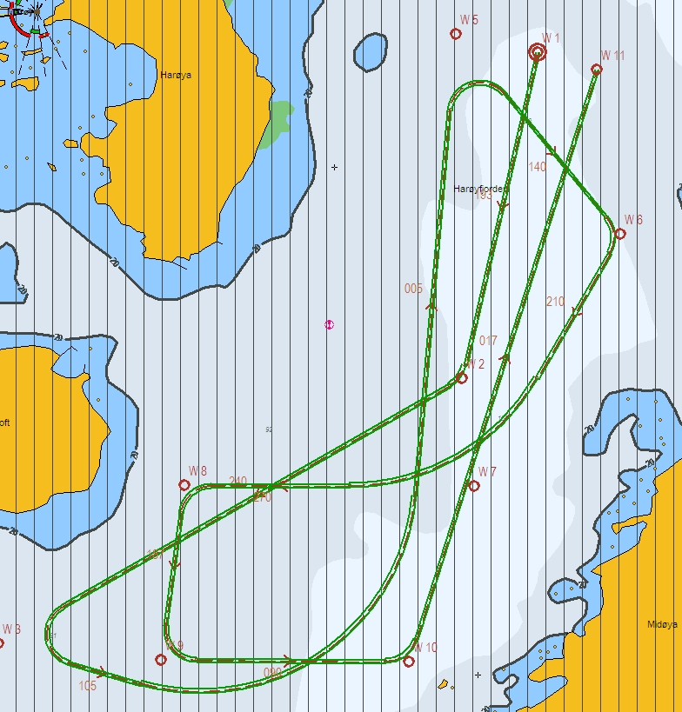
WPT 3: 135 deg turn port, WPT 5: 135 deg turn starboard (both with minimum radius*)
WPT 4: 60 deg turn port, WPT 7: 60 deg turn starboard (both with 2 NM radius)

* Minimum radius to be settled after calculations from yard.

ECDIS Scheduled Track Course 90 deg

AP Scheduled Course 90 deg
TCS Test3)
Failure point in turn.
Turn radius is with 1.0NM
Ship start turn from wheel over point with 90 deg Angle
Approach run

Trial Speed
NSR
Wheel Over Point
TCS Test 2)
Failure point
at straight leg
Pre-Warning alarm 120sec before wop

WP Approach alarm 30 sec before wop

Fail to Safe Properties
Item | Fail | Track Control (TCS) | Test | Result
1 | Position sensor antennas to be blinded off. | When either of position sensor acquisition stops, TCS emits alarm but continues to function utilizing acquired position from other position sensor, LOG, and GYRO. When both position sensor acquisition stops, TCS emits alarm but begins navigation utilizing estimated position made available by LOG and GYRO. Then it (after 10min) automatically switches to Radius mode and manual maneuver will be in effect. | Remove No.1 position sensor antenna  Remove No.2 position sensor antenna
2 | Disconnect position sensor on a straight leg. | Same as above | Remove No.1/2 position sensor
3 | Disconnect position sensor during max radius turn. | Alarm will be emitted only from ECDIS which places no influence on TCS function. | Remove No.1 position sensor output connector during maximum radius turn.
4 | Turn Heading Control System rudder limit to min value during min radius turn. | Not available. | Adjustment of rudder limit is not available.
5 | Disconnect serial  link to heading  controller during  straight leg. | Emits alarm and stops TCS function simultaneously. It automatically switches to Radius mode and manual maneuver will be in effect. | Remove Track Control connection from ECDIS while sailing straight ahead.
6 | Disconnect serial  link to heading  controller during  turn. | Emits alarm and stops TCS function simultaneously. Automatically switches to Radius mode and manual maneuver will be in effect after turning to the pre-determined maximum degree. | Remove signal cable exclusively in use for Auto Pilot outputted from ECDIS while turning.
7 | Disconnect speed log  during straight leg/  or turn. | Although emits alarm, two position sensor data inputted maintains the normal function. | Remove LOG input outputted to ECDIS while turning.
8 | Simulate failure in  ECDIS. | Same as item 5 or 6. | Turn off ECDIS
9 | Simulate failure in  conning display. | Not influential | Turn off Conning Display
10 | Disconnect rudder  feedback. | Emits alarm by Alarm System. If the deviation between order rudder angle and actual rudder angle is 5deg or more, the Alarm System emits alarm and freezes the actual rudder angle at this time. | Remove rudder feedback input outputted to Alarm System while turning.  * This test is dangerous !
11 | Simulate failure in Autopilot | Emits alarm by Alarm System and stops TCS function. Rudder angle is frozen at this time. | Remove power connection to autopilot while turning.  * This test is dangerous !
12 | Simulate failure in  No.1 gyro. | Not influential | Switches automatically  from No.1 to No.2
13 | Check that second gyro is automatic applied in case of failure in the active gyro. | Not influential
Checklists prior to completion of TECDIS TCS and TECDIS AW installation completed

Vessel Name / ID:
Date of installation:
Name of technician:
Checklist performed (Sign):

The checklists in section 6.2 shall be filled in and signed for all TECDIS installations where Track Control functionality is present (TECDIS TCS / TECDIS AW), in order to verify proper installation of the ECDIS system onboard.

Additional checklist prior to completion of TECDIS AW installation

No. | Item | Content | Result | Remarks
1 | Conning | Verify that when one of the ECDIS processors lose sensor data on one serial line, display of sensor data (relevant according to failed serial line) on conning monitor is not affected.
2 | General | Verify that installation is done according to block diagram for TECDIS AW system.
3 | General | Verify that installation is done according to functional description given for TECDIS AW system.
4 | General | Verify that required conning info according to NAUT AW requirements is displayed correctly.
5 | Gyro | Verify that requirements set forth in section 1.7 are fulfilled.

Additional checklist prior to completion of TECDIS AW installation completed

Vessel Name / ID:
Date of installation:
Name of technician:
Checklist performed (Sign):

The checklist in section 6.3 shall be filled in and signed for all TECDIS AW installations, in order to verify proper installation of the ECDIS system onboard.

