Send registration:
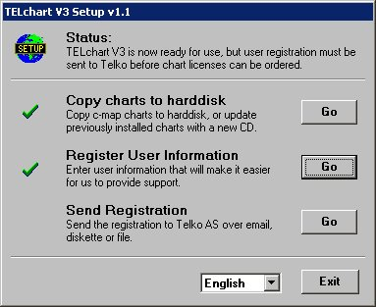
Choose ”Go” to send the registration document to
TELKO AS
This has to be done before or
When you are ordering chart

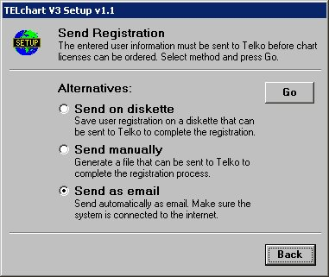

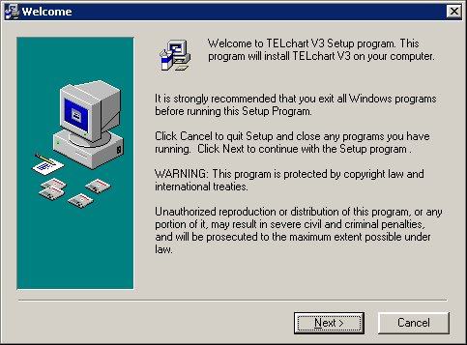
You can save the file on a floppy,

on your hard drive, or send via e-mail.

To: telchart@telko.no

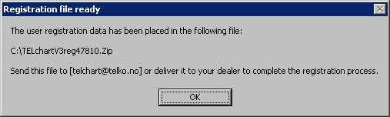
By ”send manually” the file will be saved on:
C:\TELchartV3reg48xxx.zip

Installation guide for
TELchart V3- software

For Windows 2000 and XP

(Cannot run on Win NT, 95, 98 and Me)

Install program:
-Insert program CD. Run [cd]:\setup.exe

Follow the dialogs in the setup program by clicking the
“Next” -button.

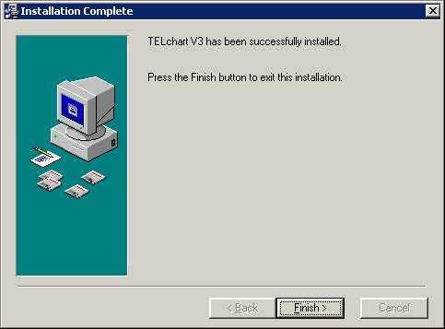
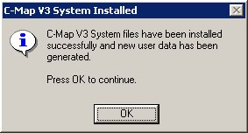

TELchart V3 is now installed.

Run TELchart V3 Setup ”icon” on desktop:

Copy map to hard drive:
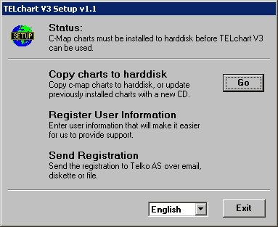

Select ”Go”

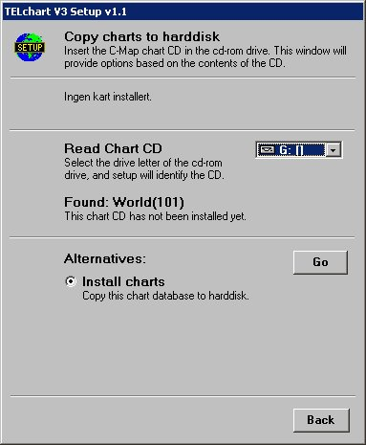
Insert the CD containing C-Map edition3 chart. Select CD drive and enter “Go” to copy chart to your hard drive.

Select ”Back” when finished.

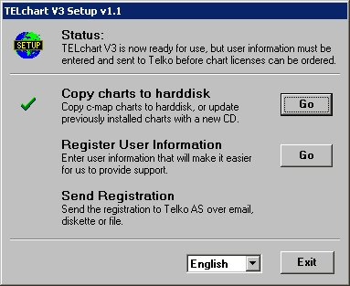
Register user information:

Select “Go” to register “User” information

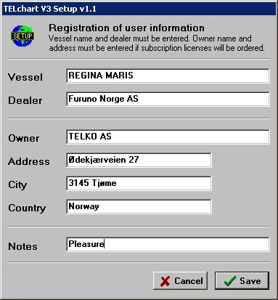
Ship owners address and callsign/MMSI
Must be filled in.

Select “Save” when finished

