Run from CD

If you do not want to copy your charts to your harddrive you can press the button "Run from CD" to make the TELchart V program search for the charts on your CD-ROM instead of your harddrive.
To quit the program press the "OK" button.

Special functions in the Telchart Setup program.

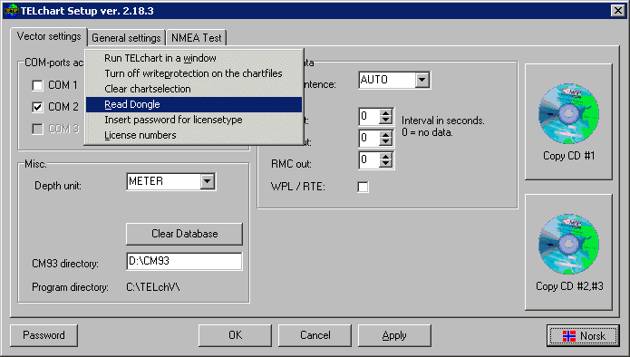
By right click the “Vector settings” tab this menu appear. Here you can
Check the “codeplug” and read the licence number etc.

Installation guide for
TELchart V - software

Install program:

-Connect codeplug on printerport.
-Insert program CD. Run [cd]:\setup.exe

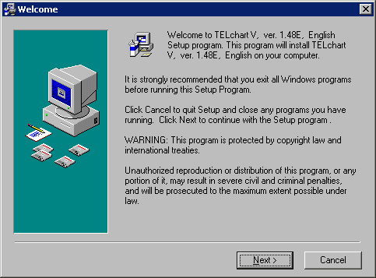

Follow the dialogs in the Setup program by clicking the "Next"-button.

After the installation has been finished the TELchart Setup is executed:

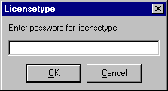
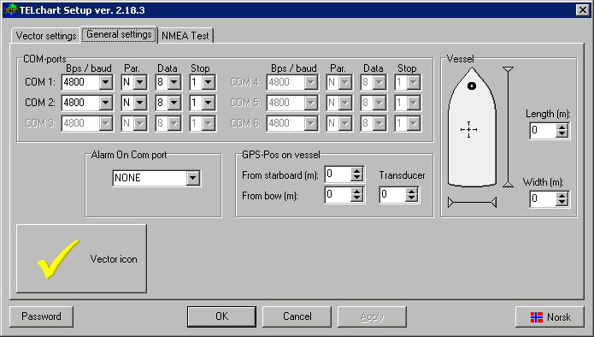

Here you must enter a password for licensetype. This password for your application should follow the softwarepack from your dealer when charts has been ordered.

Insert Chart CD in CD player and restart TELchat Setup program.
Perform Copy CD for charts as described.

Copy charts with TELchart Setup

The TELchart Setup program will appear like this when launched from the installation program.
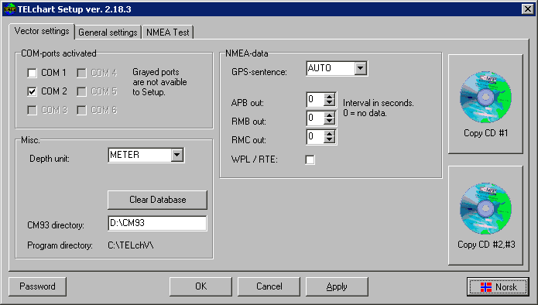
To copy the charts, insert the CD containing the C-Map's CM93 chart database into your CD-drive and press the button "Copy CD #1" in TELchart Setup.
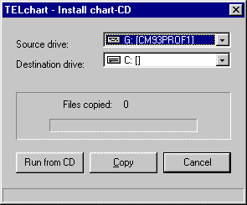
The dialog "TELchart – Install chart-CD" will pop up.
If you have already inserted your C-Map CD the program will probably find your CD as source drive. If not you must specify the source drive for your CD-ROM.
You must also specify your destination drive which by default is your C-drive.

Now press "Copy" to copy the charts to your harddisk..
If you have tree CDs in your CD-cover and want to copy the second CD, insert the second CD and press the button "Copy CD #2#3".
To quit the setup-program press "OK"

